**Assignment 8.1**

Petrol Data Analysis

Problem Statement

Column name : Column1: District.ID I4N 1M1 varchar Column2: Distributor name shell varchar Column3: Buy rate (million) $957.70 varchar Column4: Sell rate(million) $5779.92 varchar Column5: volume IN(million cubic litre) 933, int Column6: volume OUT(million cubic litre) 843, int Column7: Year 1624 int Dataset Link : https://github.com/prateekATacadgild/mAPrEDuce/commit/7f78340c5d59d229 40587bb76bec94dd4781265f

1. Write a mapreduce program to find the total amount of petrol in volume sold by every distributor.
2. Write a mapreduce program to find which are the top 10 distributors ID's for selling petrol and also display the amount of petrol sold in volume

**Task Class**

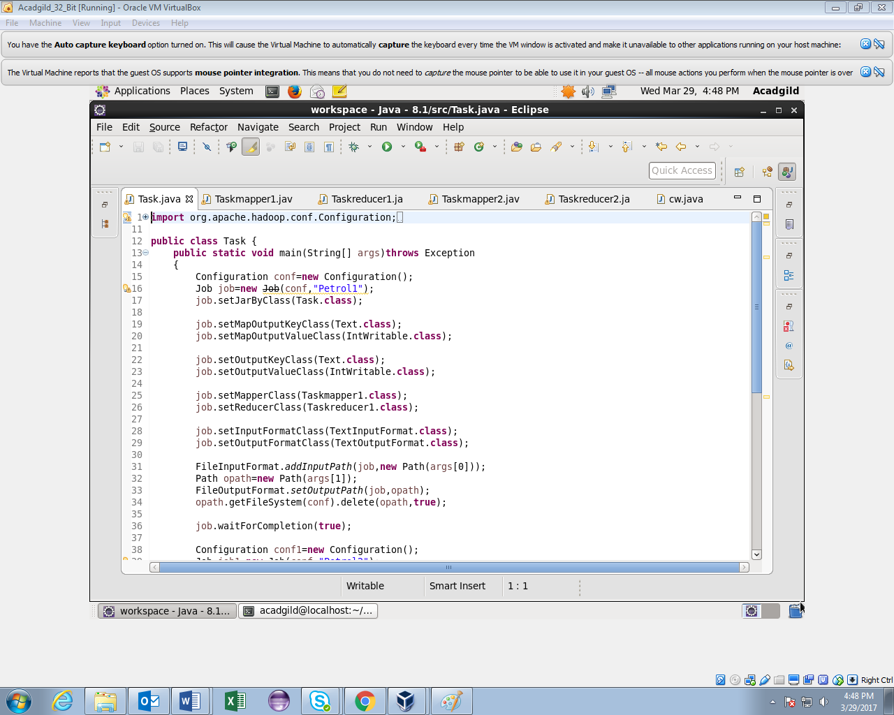

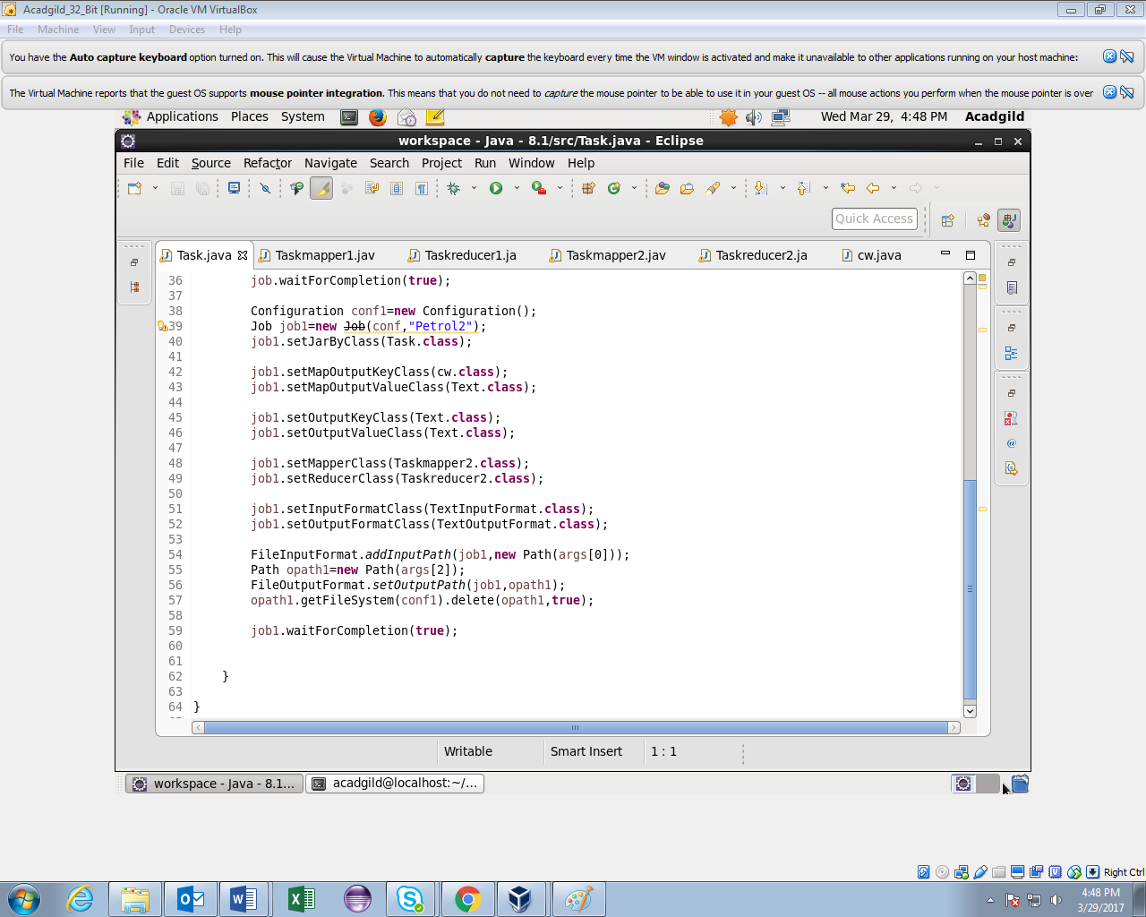

**Task1 Mapper**

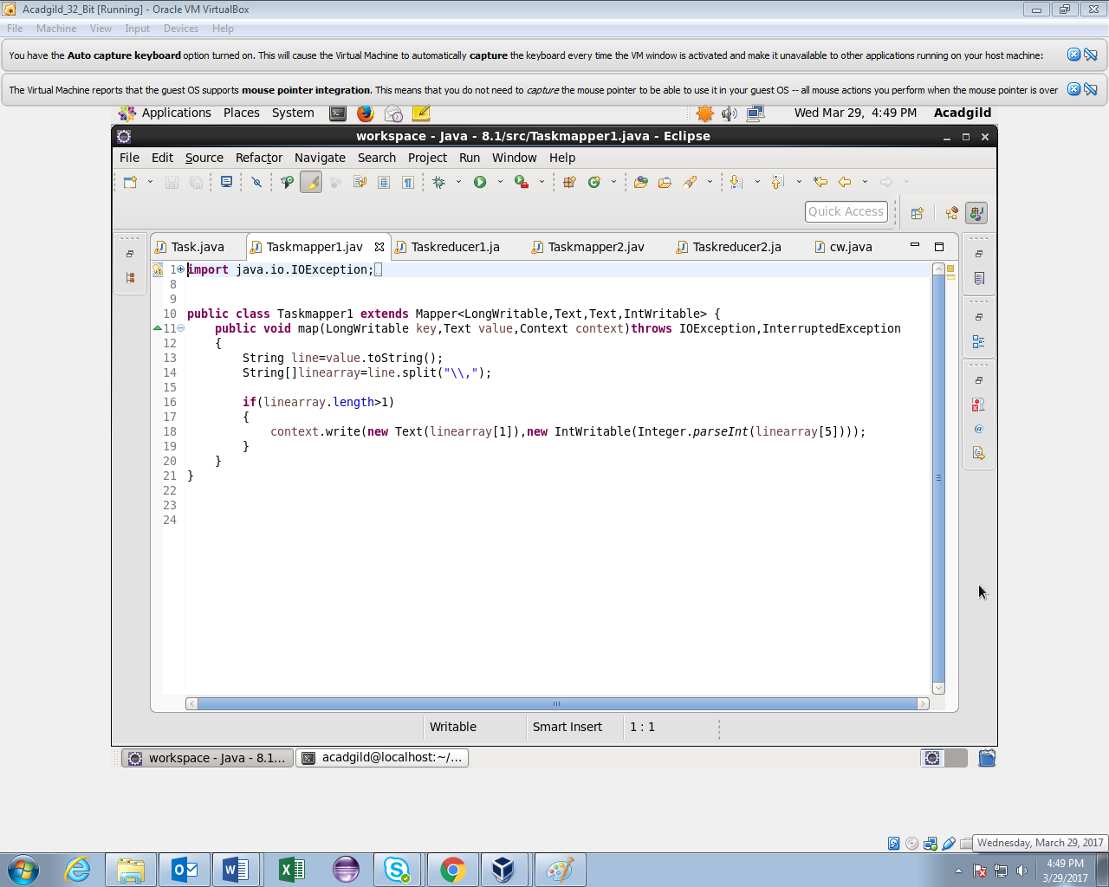

**Task1 Reducer**

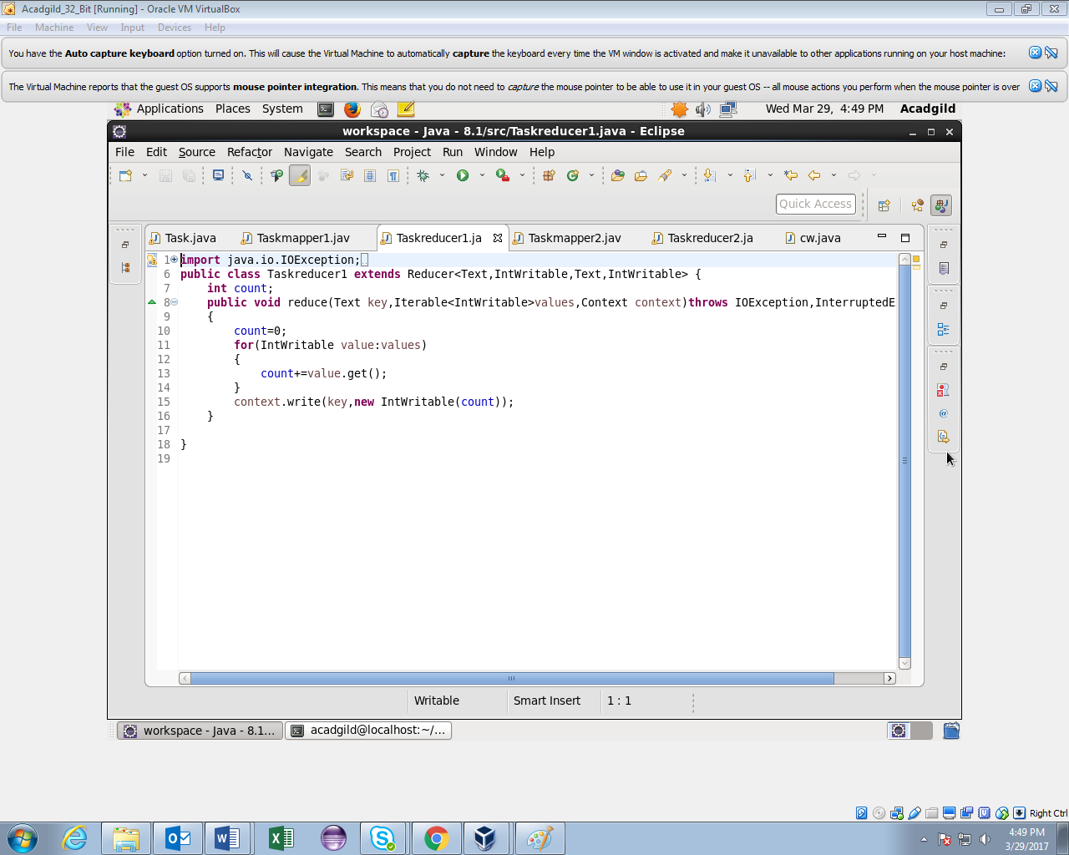

**Task2 Mapper**

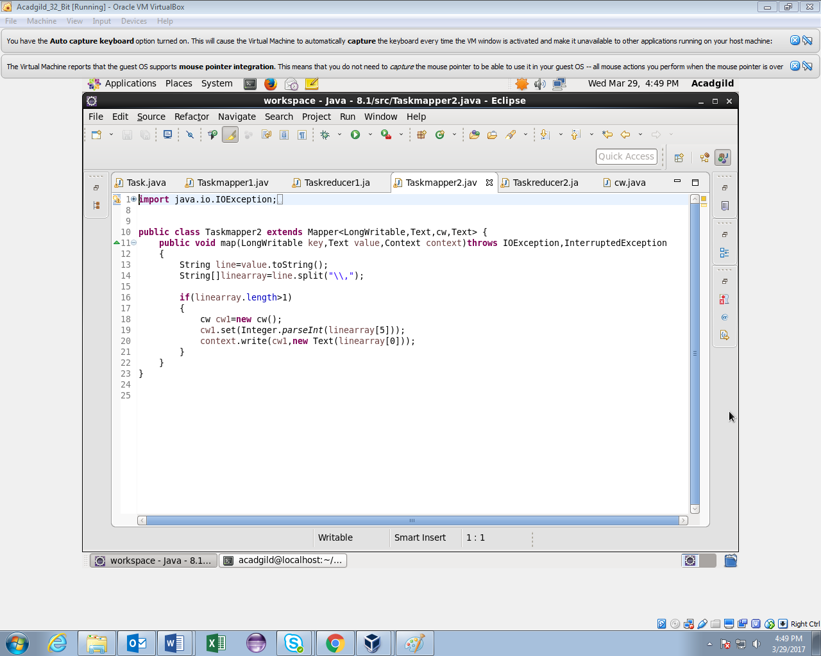

**Task2 Reducer**

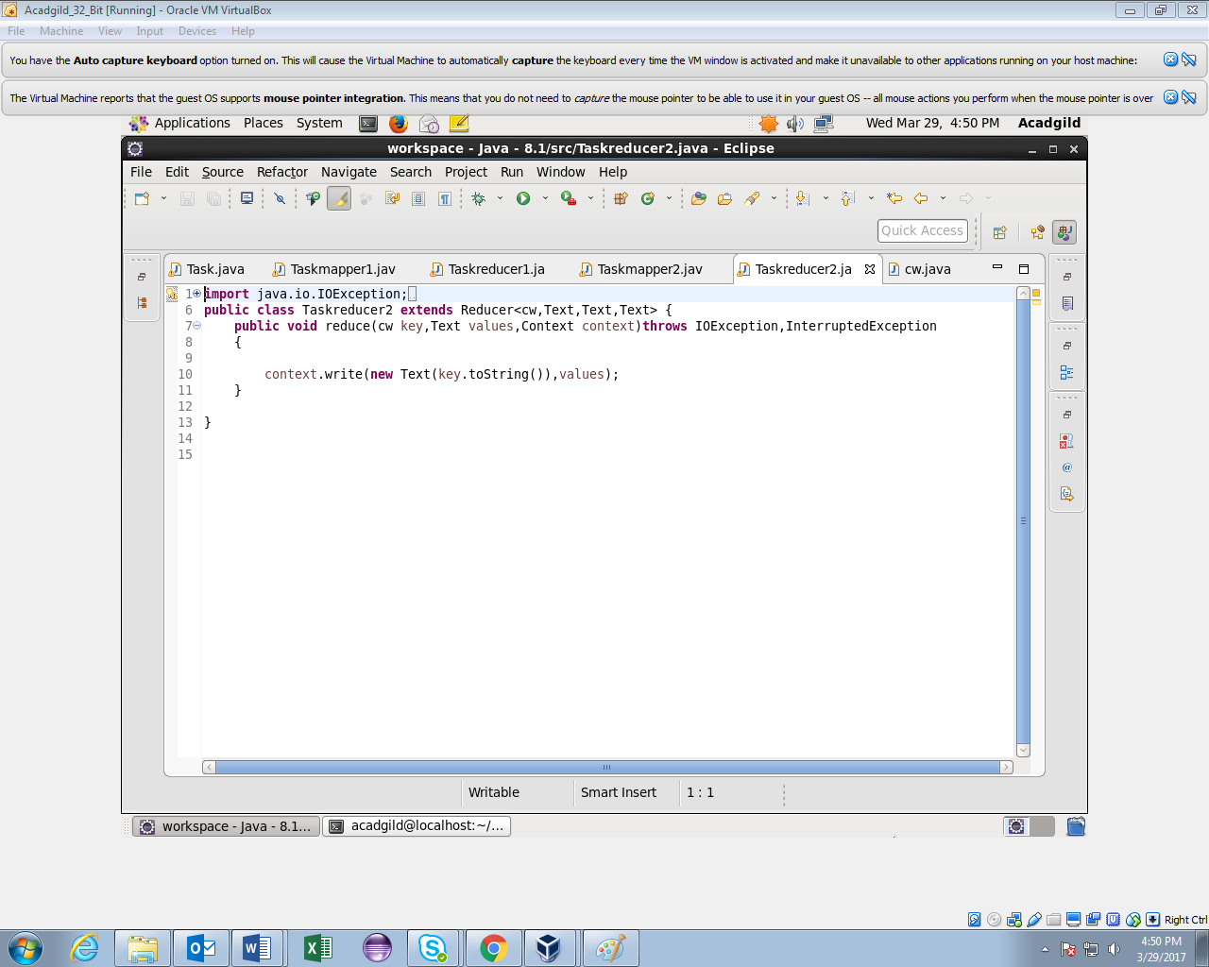

**Writable Comparable class for composite key**

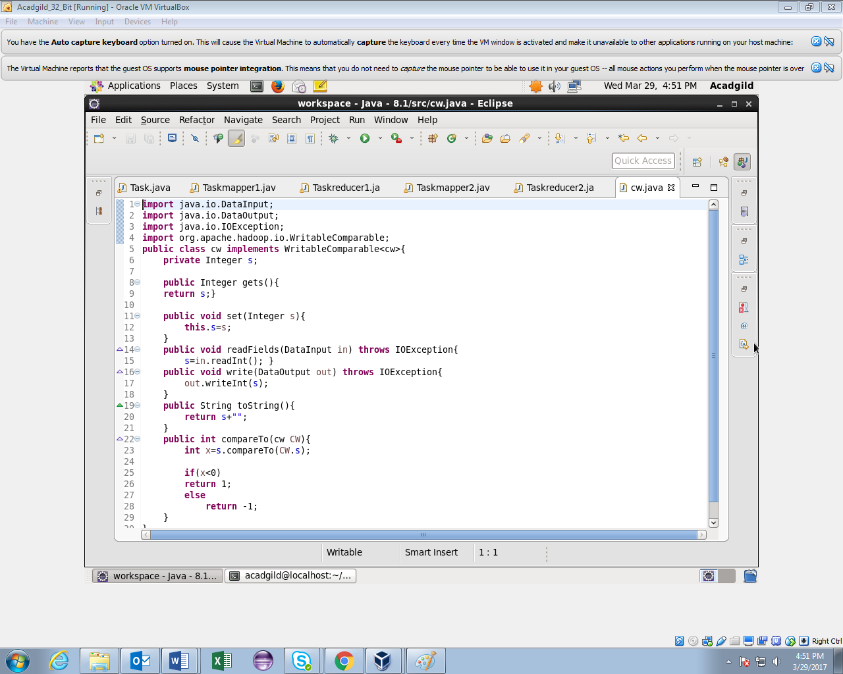

**Running Jar**

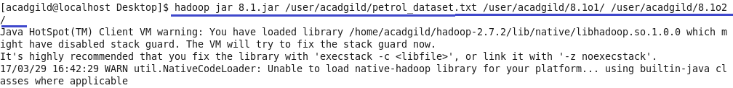

**Task1 Output**

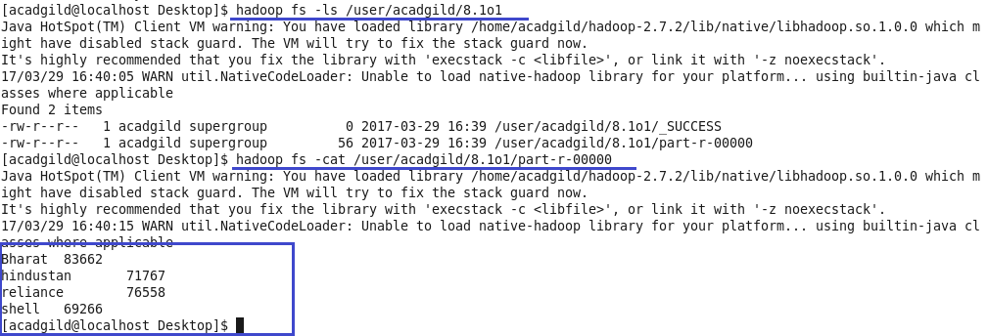

**Task2 Output**

